**EFFICIENT SOFT-SWITCHING DC-CONVERTER FOR MPPT OF A GRID CONNECTED**

**PV SYSTEM USING MATLAB**

*2*

*G.Thanmai1, K. Swathi1, B.Vaishnavi1, S.Lilleesh1,*

*Dr.K.Neelima2, Mr.V.Jeetender*

*1UG Students, EEE Department, VBIT.*

*2Professor, EEE Department,*

*VBIT. Hyderabad, India.* [*Thanmai.ganji98@gmail.com*](mailto:Thanmai.ganji98@gmail.com)

**Abstract - The analysis of soft switching front end dc-dc converter for MPPT controller of a grid connected system finds the solution to achieve obtaining maximum power point from the PV module. The expression "soft switching” ensures that the operation of power electronic switches operated only at zero- voltage called zero voltage switching (ZVS) or zero-current switching (ZCS). We are going to study the analytical comparison between buck-boost converter with soft switching and Cuk converter with soft switching and conclusion which helps to find the most efficient technique to achieve maximum power point tracking.**

**Index terms - *Solar PV, Soft switching, Buck-Boost Converter, Cuk Converter, MPPT, Perturb and Observe method, Incremental conductance method.***

**I . INTRODUCTION**

The process involved to supply one unit of electricity makes to generate two units of electricity by different technical losses and the environmental pollution created by that process emits the dangerous gases and polluted the environment which affects the human health. In solar power plant the efficiency of the plant is highly dependent upon the solar radiation, temperature, and load resistance[2]. Then the storing of electricity generated from the solar power plant after satisfying the demand is another difficult task. As we know that the storing of all the power which is generated from the PV module is difficult so, the highly possibility is to connect it to the grid , but again connecting PV modules to the grid is not that easy task because the output of PV array needs to be boosted using DC-DC converter[3-

5]. In order to get the maximum output from the PV arrays, the panel must operate at maximum power point (MPP) technique by which the operating point of the plant keep changes continuously according to the weather and ensures the maximum output point. So it require maximum power point tracking (MPPT) controller techniques[5]. The purpose of the MPPT is to adjust the output of PV voltage close to the MPP

even under the changing atmospheric condition. There are many techniques and methods are available to obtain and achieve MPPT and they are indirect method of fixed voltage method (FVM)[6], indirect method of fractional open circuit voltage method[7], direct method of perturb and observe method[8], and direct method of incremental conductance method[9]. The desired MPPT function can be obtained by dc-dc converter in boost mode or buck boost mode.

The storing and utilization of electrical energy produced by PV system will be efficient to the fullest if we use MPPT (Maximum Power Point Tracker) between grid (or storing device) and the PV arrays. However to make the system yet more practically reliable a fast soft switching system should be combined with the MPPT. The three basic topologies for this purpose are the Buck (Down), Boost (Up) and Buck-Boost (Up-Down) converters along with switching transistors, diodes, capacitors and control algorithms.

**II. PROPOSED SOFT SWITCHING CUK CONVERTER**

A. Proposed converter circuit

Fig 1 shows the proposed soft switching Cuk converter capable of minimizing the switching losses. A switch, a diode, and the inductor and capacitor are added in the proposed circuit. The two switches are controlled on and off simultaneously. Also, the switching loss is reduced by soft switching utilizing the resonance between inductor and capacitor.

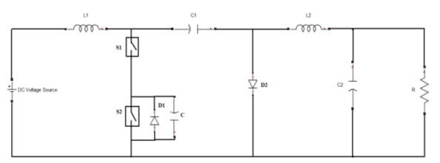

*Fig.1 Schematic representation of Cuk Converter with zero voltage switching*

B. Operation of CUK converter

The basic CUK converter can be inspected in the fig.3.20. If the VC and VCO polarities are in the reverse direction of the loop considered and the current must increase, the current must actually increase in the opposite direction of the assumed direction .

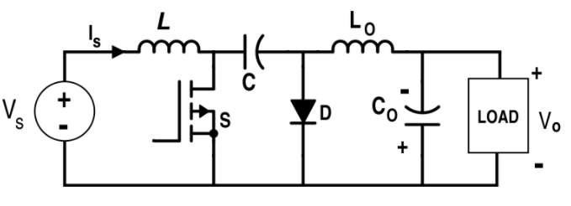

inductor current decreases. At the same time, the energy stored in the inductor Lo is transferred to the load thereby the current of inductor IL0 declines. As a result, the current through Lo, D, load forms a current loop.

**-VS+VC+VL=0 (6)**

**di/dt = -(Vc-Vs)L (7)**

For inductor Lo

**VL0-VC0=0(Current decreases) (8)**

*Fig.2 CUK converter with MOSFET*

**Interval 1**: Mode 1 shows when the switch S is turned on, the equivalent circuit has been shown in fig.2. In this mode, the source Vs charge the inductor as a result, the current through the inductor L rises. The current through Vs, L, S forms a current loop. Meanwhile, since VC>VO, the capacitor C discharge and the diode D has the inverse voltage which is regarded as open circuit. The energy stored in the capacitor was transferred to capacitor Co and load and inductor Lo. In the other words, ***the*** voltage of capacitor Co increases and the current of inductor rises. The current through C, S, load dfLo forms another current loop.

**VS =VL (1)**

**L0 di/dt =VC0 L(Current decreases) (9)**

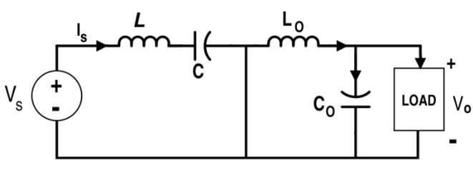

*Fig.4 When the switch S is off (Mode 2)*

Because the inductor L is the source when the switch is off and the IL decreases therefore it should be positive. It is apparent that the charging time of capacitor C is1-D*T,

**Vs=L* di/dt**

**(2)**

**ΔVc=ΔQc=IC integral(-D-*TIC dt=Is(1-D)*TC (10)**

For inductor L0,

**ΔIL=VS*D*TL (3) (Current decreases)**

**VC +VL0+V0=0 (4)**

**IC=IS (11)**

Inspection of the condition of volt-sec balance

**VS*D*T=Vc-Vs*(1-D)*T (12)**

**L0 (dI/dt) = -IL*(VC+V0) (5) (Current decreases)**

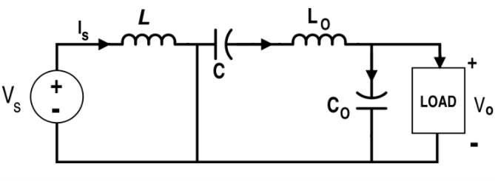

*Fig.3When the switch S is on (mode 1)*

**Interval 2**: When the switch is off, the equivalent circuit can be inspected in the fig 3. In this mode, the capacitor C is charged by supply voltage and inductor L as the source through the inductor L and diode D. what’s more, because of the Voltage VC>VS, the

**VC=1(1-D)VS (13) VC+VC0*D*T=-VC0*(1-D)*T (14) VC*D=-VC (15) VC0=-(D/1-D)*VS (16) V0=-VC0 as well**

**V0=(D/1-D)*VS (17)**

Because of the condition of the capacitor C charging balance

**IL=I (18) IL0=Io (19)**

The assumption is that there is no loss in this converter

**Pin = VS*IS (20) Pout=Vo*Io (21) VS*IS=D/(1-D)*VS*I0 (22) IS = (D/1-D)I (23) I0 = V0R (24)**

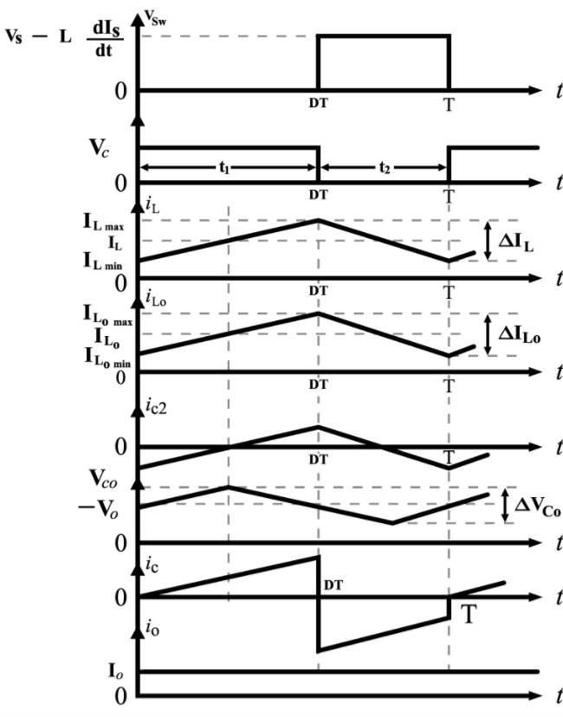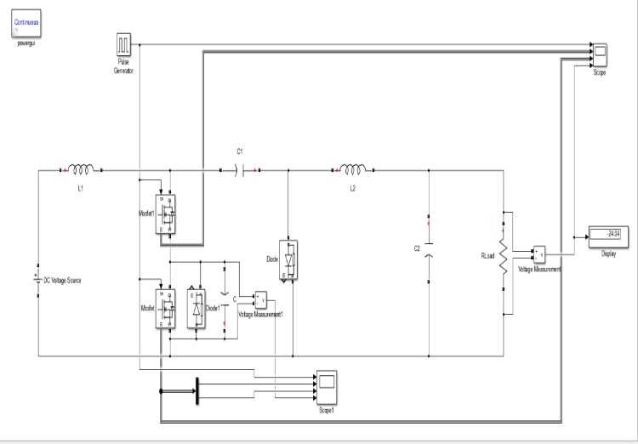

*Fig.6 Simulink Model Of Cuk Converter*

Table.1 The Simulation parameters

**PARAMETERS VALUE** Input Voltage 100V Load Resistance 10 Ω Input Inductor 10 mH Output Inductor 115 mH

Coupling Capacitor 22µF Output Capacitor 220µF

Frequency 50KHz

*Fig.5 Switch (S) Voltage, Capacitor (C) Voltage, Inductor (L) Current, Inductor (LO) Current, Capacitor (CO) Voltage, Capacitor (C) Current and Load Current respectively for the CUK Converter*

**III. SIMULATION RESULTS**

Fig. 4 shows a Simulink model of the proposed soft switching Cuk converter.

Capacitor across switch

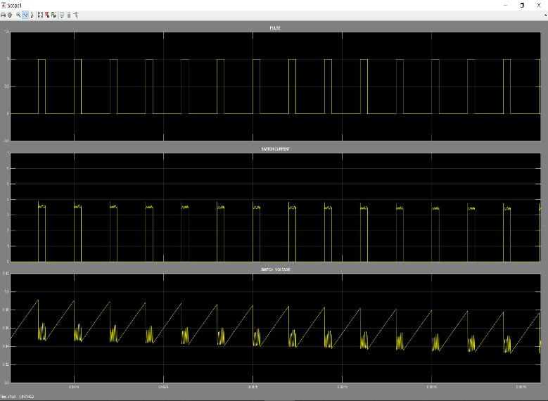

47 µF

*Fig.7 Output Waveforms Of Cuk Converter across the switch*



*Fig.7 Output voltage waveform of Cuk converter across the load*

**IV CONCLUSION**

In this project, switching losses across the switch and ripples in the circuit have been reduced using Cuk converter with soft switching compared to the buck boost converter. Using soft switching the energy generated from the power grids can be utilized with minimal drop or losses across the switch during switching process.

This project suggests that the circuit constituted by an auxiliary switch, diode and capacitor to the Cuk converter circuit. This interleaved technique reduces the input current ripples and output voltage ripples. The proposed soft- switching achieves Zero Voltage Switching by the resonant Capacitor when the Switch is turned off. Thus the proposed circuit can reduce switching losses.

and Boost Buck inverter topologies as a single phase transformerless photovoltaic grid connected power conditioner” in IEEE Power Electronics specialist conference (PESC), 2006, pp 1-6.

[5] H.Behjati and A Davoudi “A multiple input multiple output DC – DC converter” IEEE Transaction on Industry Application vol.49. pp-1464- 1479, 2013.

[6] H.Keyhani abd H.A. Toliyat “ A New generation of buck-boost resonant AC-Link Dc-DC converter” in IEEE Applied Power Electronics Conference and Exposition(APEO) 2013, pp 1383-1390.

[7] P.S.Shenoy, K A kim, B.B.Jhonsons, and P.T.Krein” Differential power processing for increased energy production and reliability of photovoltaic systems” IEEE Transaction on power electronics. Vol 28.pp-2968-

2979,2013 [8] M.Hamzeh ,S.Farhangi, B Farhangi “ A new

control method in PV grid connected inverters for anti- islanding protection by impedance monitoring” in IEEE workshop on control and modeling for power electronics(COMPEL) 2008, pp 1-5.

[9] A.R.Kashyap, R.Ahmadi and J.W.Kimball “ Input voltage control of SEPIC for maximum power point in IEEE power and energy conference at Illinois (PECI),

2013. pp 30-35 [10] A.Ahmadi, A.Kashyap, A.Berrueta Irigoyen , A.Rayachoti, C.Wright and J.Kimnall “ Selective source power converter for improved photovoltaic power utilization” in IEEE power and energy conference at

Illinois (PECI), 2013. Pp 247-252.

[11] D.Sera, T.Kerekes, R Teodorescu and F.B Laabjerg

“Improved MPPT

[12] A. Safari and S. Mekhilef, ”Incremental Conductance

MPPT Method for PV Systems”, in Proc. 24th Canadian Conf., IEEE Electrical and Computer Engineering, pp.000345 - 000347, May 2011

[13] B.Abdi, A.Safaei, J.S.Moghani, H.Askariyan

Abyanesh, “An overview of soft switching converter for

Photovoltaic” International Journal of Communication and

Electrical Engineering. Vol.5. no.1. Feb 2013.

In this project, soft switching of a cuk converter is analyzed using MATLAB Simulink model, designed a Simulink model and observed the input pulse, input voltage and currents and output voltage and currents across the switches, diode and load. This circuit helps to reduce switching losses of a grid connected systems.

**REFERENCES**

[1]. Efficient Soft-Switching dc-dc converter for MPPT of a Grid Connected PV System BY Ambikapathy,*Dept. of Electrical. & Electronics Eng.* International Conference on Computing, Communication and Automation (ICCCA2016).

[2] A.Ambikapathy. Gajendra Singh, Prabhakar Tiwari, “Significance of saving one unit of Electricity”, 1st UPCON-ICEEE2015, 26-28th March, l2015, IEEE

explore, pp1-6. [2] Z.peng, W.yang, X.Weidong, and L.Wenyuan ”Reliability evaluation of grid connected photovoltaic power system” IEEE Transaction on sustainable energy.vol.3. pp 379-389. 2012. [3] M.Kasper,

D.Bortis, T.Friedi and J.W.Kolar, “ Classification and comparative evaluation of PV panel intergrated dc-dc converter concepts” in IEEE power electronics and motion control conference (EPE/PEMC), 2012,pp-LS1e4-LS1e.4-

8.

[4] B.Farhangi and S. Farahangi “ Comparison of z source